Fake News Detection Project

**Project idea –** Fake news spreads like a wildfire and this is a big issue in this era. We can learn how to distinguish fake news from a real one. We can use supervised learning to implement a model like this.

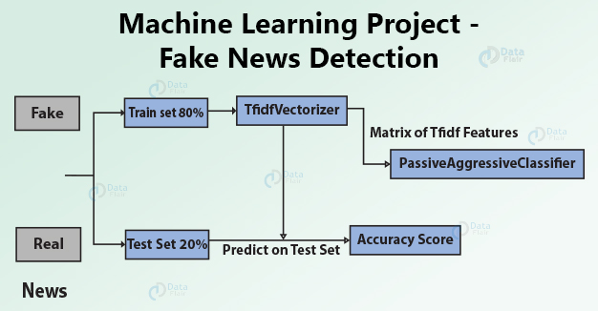

Details about this project:

<https://data-flair.training/blogs/advanced-python-project-detecting-fake-news/>